Muhammad Maaz 24P-3032 BSE-1B. PF-LAB

Lab 13: Question.1:

Code:

#include<iostream>

#include<iomanip>

using namespace std;

int stds;  //stds = students.

float average( int* );

int max( int* );

int min(int*);

int main()

{

    int max_size=10;

    cout<<"\n\tWell Come"<<endl;

    cout<<"This program will find average, highest, lowest marks. "<<endl;

    cout<<endl<<"Enter the number of students: ";

    cin>>stds;

    if(stds>max_size)

    {

        cout<<"Invalid Iuput! Enter Number between 1-10 only.\nProgram Terminated "<<endl;

        return 1;

    }

    int stdlist[stds];   //stands for "students list".

    int i=0;

    do

    {

        cout<<"Enter Marks of Student "<<i+1<<": ";

        cin>>stdlist[i];

        i++;

    } while (i<stds);

    cout<<setprecision(3)<<showpoint<<fixed<<endl;

    cout<<"\n\nThe Average Marks are: "<<average(stdlist)<<endl;

    cout<<"The Highest Marks are: "<<max(stdlist)<<endl;

    cout<<"The Lowest Marks are: "<<min(stdlist)<<endl;

    return 0;

}

//Function to find average.

float average( int* marks )

{

    int sum = 0;

    int i=0;

    while(i<stds)

    {

        sum+=*marks;

        marks++;

        i++;

    }

    return (sum*(1.0))/stds;

}

//Function to find highest.

int max(int* marks)

{

    int highest = *marks;

    int i=0;

    while(i<stds)

    {

        if(*(marks)>highest)

        {

            highest = *marks;

        }

        marks++;

        i++;

    }

    return highest;

}

//Function to find lowest.

int min(int* marks)

{

    int lowest = *marks;

    int i=0;

    while(i<stds)

    {

        if(*(marks)<lowest)

        {

            lowest = *marks;

        }

        marks++;

        i++;

    }

    return lowest;

}

**Screenshot Output:**

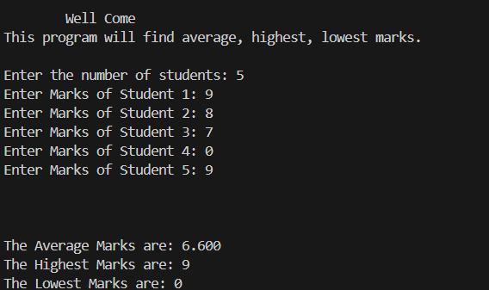

**Please see next page.**

**Question.2:**

**Code:**

#include<iostream>

using namespace std;

int main()

{

    int size;

    cout<<"Enter the size of array: ";

    cin>>size;

    if(size>15 || size<0)

    {

        cout<<"Invalid input!";

        return 1;

    }

    int array[size];

    int freq[size];

    int *arrptr=array;

    int *freqptr=freq;

    for(int i=0;i<size;i++)

    {

        *(freq+i)=0;

    }

    cout<<"Enter the Numbers: "<<endl;

    for(int i=0;i<size;i++)

    {

        cin>>*(arrptr+i);

    }

    for(int i=0;i<size;i++)

    {

        for(int j=0;j<size;j++)

        {

            if(arrptr[i]==arrptr[j])

            {

                (*(freq+i))++;

            }

        }

    }

    for(int i=0;i<size;i++)

    {

        cout<<i+1<<": "<<*(arrptr+i)<<" is repeated "<<*(freqptr+i)<<" times "<<endl;

    }

    int max=*freqptr;

    int modeindex;

    int i=0;

    while(i<size)

    {

        if(max<*(freq+i))

        {

            max = *(freqptr+i);

            modeindex=i;

        }

        i++;

        continue;

    }

    cout<<"The mode is "<<*(arrptr+modeindex)<<", apppearing "<<max<<" times"<<endl;

    return 0;

}

**Screenshot output:**

